Morphological Operations Using Erosion
Experiment No: 29
Aim
To perform the morphological erosion operation on an image using OpenCV in Python.
Tools Required
- Python 3.x
- OpenCV (cv2)
- NumPy
- VS Code / PyCharm / Jupyter Notebook
- Input image (image.jpg)
Theory
Erosion is a morphological image processing operation that reduces the boundaries of foreground objects. It is mainly used to remove small unwanted regions and separate objects that are connected.
The erosion operation is performed using a structuring element (kernel).
Procedure
- Install OpenCV and NumPy:
Bash
pip install opencv-python numpy
- Read the input image using OpenCV.
- Convert the image to grayscale.
- Create a structuring element (kernel).
- Apply the erosion operation using cv2.erode().
- Display the original and eroded images.
- Save the resulting image.
Code
import cv2
import numpy as np

# Read the image
image = cv2.imread("image.jpg")

# Check if image is loaded
if image is None:
print("Error: Image not found!")
exit()

# Convert image to grayscale
gray = cv2.cvtColor(image, cv2.COLOR_BGR2GRAY)

# Create a structuring element
kernel = np.ones((5, 5), np.uint8)

# Perform erosion
eroded = cv2.erode(gray, kernel, iterations=1)

# Display original image
cv2.imshow("Original Image", gray)

# Display eroded image
cv2.imshow("Eroded Image", eroded)

# Save the eroded image
cv2.imwrite("eroded_image.jpg", eroded)

cv2.waitKey(0)
cv2.destroyAllWindows()
Output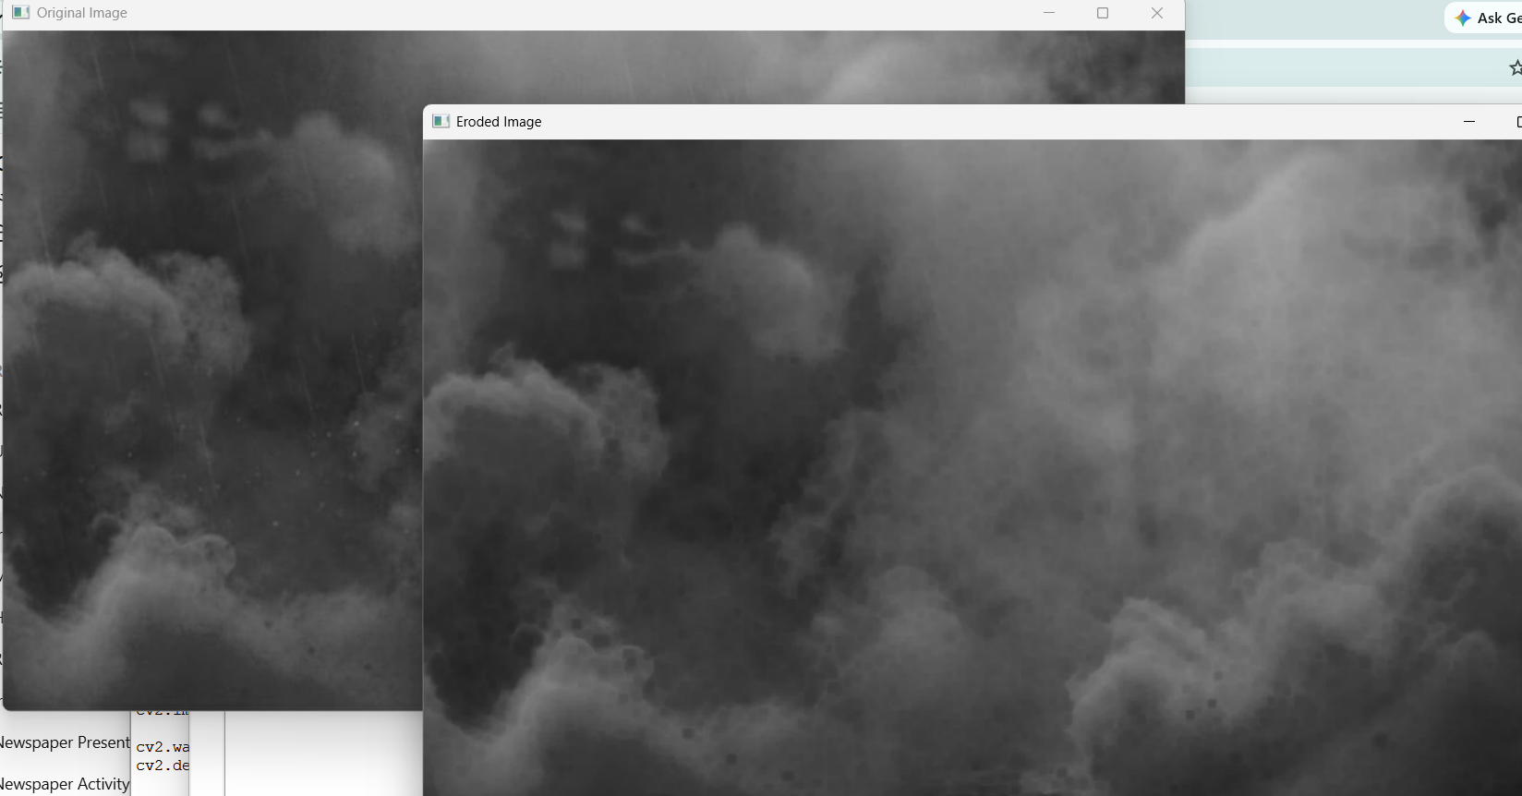
Result
The morphological erosion operation was successfully performed using OpenCV. The cv2.erode() function with a 5 × 5 structuring element reduced the boundaries of the foreground objects and produced the eroded image successfully.

